Focus Group
Jiangsu Focus New Energy Technology Co., Ltd.
Limited Quality Assurance Terms for Photovoltaic Modules
Compiling | To examine | Approval
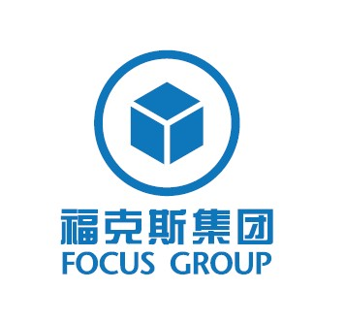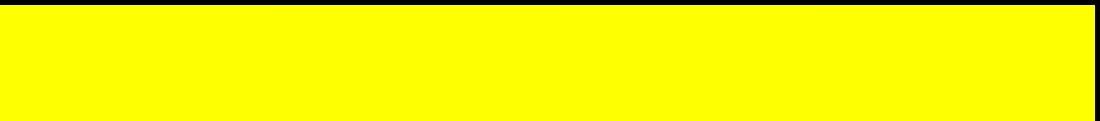

Change summary
Edition
date
Compiling
Yangchun
main

According to the company's business development and
customer requirements to develop the quality assurance clause.
OR
2017-11-23

Catalog
1
2

3
4
5
6
7
8
9
10
11
12
13
-Module type.............................................................................................................................................3
-Limited Product Quality Assurance - Ten Years of Maintenance, Replacement or Refund Compensation......................................................................................................................................3
-Limited Peak Power Quality Assurance-Limited Remedial Measures......................................3
-Exclusion and limitation........................................................................................................................4
-Limitation of liability for quality assurance..........................................................................................4
-Performance of Quality Assurance....................................................................................................5
-Separability.............................................................................................................................................5
-Technical disputes.................................................................................................................................5
-Other........................................................................................................................................................5
-Assignment of Quality Assurance........................................................................................................5
-Force Majeure........................................................................................................................................5
- Effect.......................................................................................................................................................6

- Applicable law and dispute settlement..............................................................................................6

页码
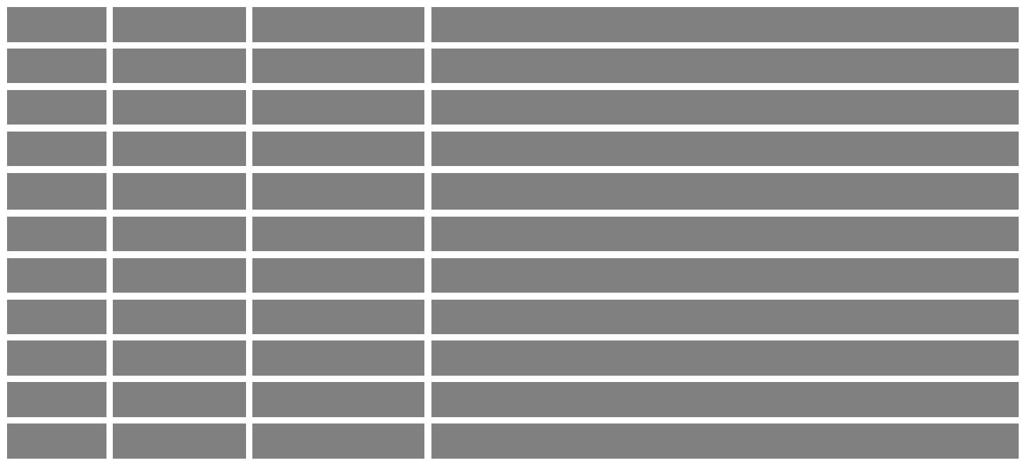

Standard solar cell assemblies for the above models，Focus will ensure the performance of its photovoltaic solar modules，The guarantee period is calculated from the date shown on the invoice from Focus to the direct customer (hereinafter referred to as "customer").

2 - Limited Product Quality Assurance - Ten Years of Maintenance, Replacement or Refund Compensation
Within 10 years from the start of the warranty period, if there is a defect in the quality of the components, it will be decided by Focus to repair or replace the products, or refund to the customer at the prevailing market price of the components. Maintenance, replacement or refund under this Article shall be the only exclusive remedy provided under "Limited Product Quality Assurance" and shall not exceed the 10-year warranty period specified in this Article. This "Limited Product Quality Assurance" does not include specific power output (this item will only be specified in Clause 3 "Limited Peak Power Quality Assurance" below).

3- Limited Peak Power Quality Assurance-Limited Remedial Measures
Within 25 years from the start of the warranty period, the actual output power under the standard product conditions decreases relative to the nominal power specified in the Focus product data. Focus will pledge:
● For the above type of photovoltaic components, Focus guarantees that the factory test power is 0 ~+5W tolerance.
● For polycrystalline series components, the power output reduction in the first year is less than 2.5% of the nominal power. After that, the output power decreases linearly, and the output power is not less than 80% of the nominal power in the 25th year from the beginning of the warranty period.
● For single crystal series components, the power output of square single crystal series components is reduced by 3.5% less than the nominal power in the first year. After that, the output power decreases linearly, and the output power is not less than 80% of the nominal power in the 25th year from the beginning of the warranty period.

If the output power attenuation of any component exceeds that described above on the start date of the warranty period and Focus determines that the loss of the power is due to defects in raw materials or processes, It will be decided by Focus:
● Provide additional components to customers to compensate for power loss, or replace defective components to eliminate power loss, or refund the cost of components to customers in proportion (calculated at the current component market price) when the difference between the actual power output and the nominal power specified in the Focus product data exceeds the portion guaranteed above.

Model Name称
1
- Module type
Explain
156-72 Polycrystalline series
156-72 Single Crystal Series
156-60 Polycrystalline series
156-60 Single Crystal Series

Jiangsu Focus New Energy Technology Co., Ltd.（Hereinafter referred to as " Focus "）Produced for it Crystalline silicon for ground use.Photovoltaic modules (hereinafter referred to as "components") provide limited quality assurance.
Component product models covered by the warranty include：
FSX***M-24/Ab(***=255-320)

FSX***S-24/Ab(***=275-335)

FSX***M-24/Bb(***=255-275)

FSX***S-24/Bb(***=275-285)
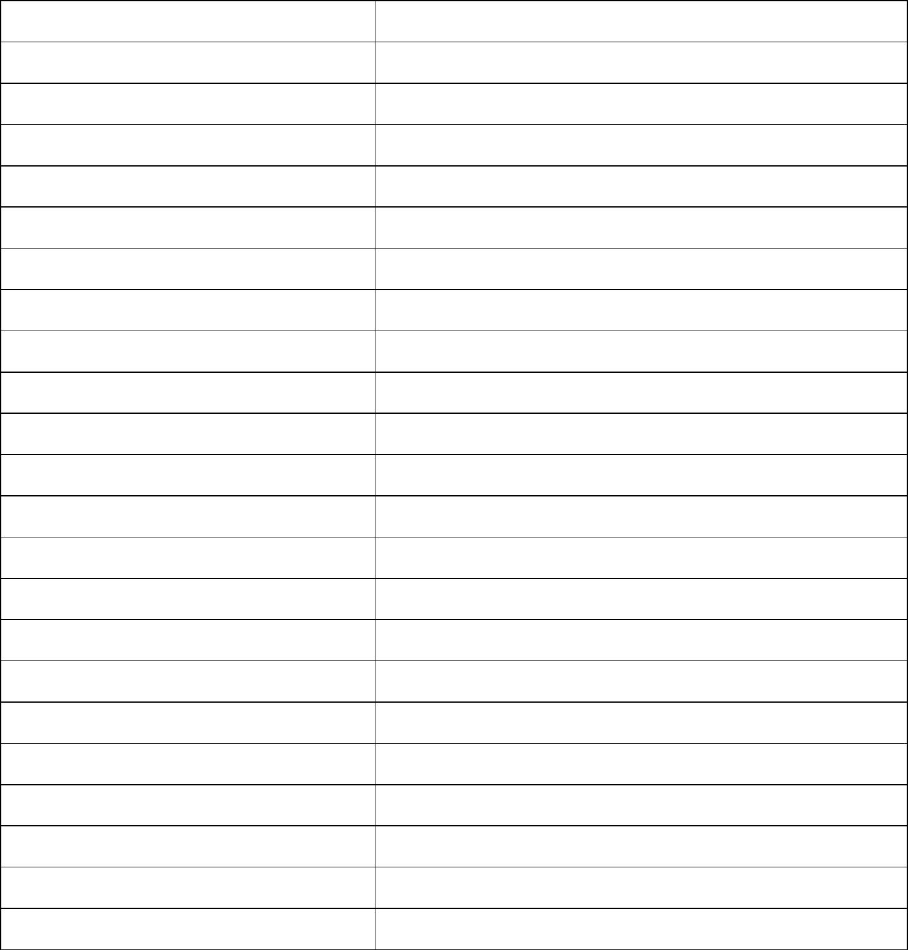

The remedies provided for in this article shall be the only exclusive remedies provided under "Limited Peak Power Quality Assurance".
4- Exclusion and limitation

(1) In any case, all quality assurance requirements must be put forward within the corresponding quality assurance period in order to be effective.
(2) The "Limited Product Quality Assurance" and "Limited Peak Power Quality Assurance" of components are not applicable to components subjected to the following circumstances:
● Misuse, abuse, negligence or accident;
● Damage caused by modification, improper installation or use, or transportation for which the customer is responsible;
● Failure to follow Focus installation and maintenance instructions;
● Maintenance or modification of maintenance technicians not recognized by Focus;
● Blackouts, lightning, floods, fires, accidental damage, third-party actions or other events beyond the reasonable control of Focus.
● Damage due to abnormal environmental conditions, including but not limited to improper voltages, acid rain, volatile or marine environments, other pollution or damage due to assembly mounted on defective buildings.
● Damage caused by external corrosion or similar discoloration of components.
● Damage caused by moving from the original installation location.
(3) "Limited Product Quality Assurance" and "Limited Peak Power Quality Assurance" do not include the following costs: costs associated with the installation, disassembly or reinstallation of photovoltaic components (except as specified in the last paragraph of Article 6 of the Essential Guarantee); customs clearance or any other costs incurred by returning photovoltaic components.
(4) The buyer failed to pay the goods in time as stipulated in the agreement.
(5) When the component model or serial number is changed, removed or unrecognizable, the quality assurance request will be rejected.
(6) This "Limited Quality Assurance for Photovoltaic Modules" does not apply to components marked as "A" or "B". Focus made it clear that there was a special "Limited Quality Assurance for Class A PV Modules" or "Limited Quality Assurance for Class B PV Modules" for such components.
5- Limitation of liability for quality assurance

Unless Focus expressly agrees, signs and agrees to other obligations and responsibilities in writing, the "Limited Quality Assurance for Photovoltaic Modules" provided in this article explicitly replaces and excludes all other express or implied guarantees (including, but not limited to, commercial guarantees applicable to special purposes, uses or applications). And all other obligations or responsibilities of Focus.

Under no circumstances shall Focus be liable for any incidental, indirect, special or punitive loss arising from breach of the Essential Guarantee, including, but not limited to, loss of profits or income, loss of business opportunities, loss of production, loss of goodwill, regardless of the type of claim, and even if Focus has been informed The possibility of such loss.

If Focus is liable for damage or other liability to the customer, its cumulative liability shall not exceed the invoice value of the order containing defective components paid by the customer.

页码
5
9

6- Performance of Quality Assurance
If the customer considers that due quality assurance requirements can be made according to the "Limited Quality Assurance for Photovoltaic Modules", he or she shall immediately send a written notice in the form of a registered letter to the back address of Focus, or send an e-mail to the following Focus Jiangsu e-mail address. Customer should attach quality assurance note, corresponding component serial number and purchase date with notification. At the same time, the contract number should be clearly displayed, and the purchase date, purchase price, component model, Focus or its distributor's signature should also be submitted as evidence.
If Focus did not issue a written authorization in advance, the returned photovoltaic components would not be accepted.
Under "Limited Product Quality Assurance" and "Limited Peak Power Quality Assurance", the reasonable and usual cost of shipping repaired or replaced components is borne by Focus.

7- Separability
If a part of this Limited Quality Assurance for Photovoltaic Modules, a project provision or a clause, or its application to a person or a situation, is deemed invalid or unenforceable, the determination will not affect the validity of all other parts, provisions, clauses or applications of this Limited Quality Assurance for Photovoltaic Modules, and for this purpose The other parts, provisions, provisions or applications of this "Limited Quality Assurance for Photovoltaic Modules" shall be deemed to be separable.

8- Technical disputes
Any technical disputes arising from quality assurance claims shall be settled by international first-class testing institutions, such as the Fraunhofer Institute of Solar Energy Research (Fraunhofer ISE in Freiburg/Germany), Rhine TUV Rheinland, VDE or PTL (Arizona State University, PTL in Arizona State University) in Freiburg, Germany. ) Unless otherwise specified, all test costs shall be borne by the ultimate losing party. The final choice of the aforementioned institution belongs to Focus.

9- Other
Maintenance, replacement or provision of additional components does not mean that the warranty period starts anew, nor should the original "limited warranty for photovoltaic modules" be extended. Any replaced components are Focus 's property and are disposed of at its sole discretion. In the course of processing the claim, if Focus ceases to produce the product of the replaced component model, it has the right to provide another model (different size, color, shape and/or power) of the component.

10 - Assignment of Quality Assurance
Components are still installed in the original installation location and can be transferred by the Essential Guarantee without disassembly or transfer, and the transferee must own the component or use the project of the component and must obtain the prior written consent of Focus before the Essential Guarantee can be transferred.

11 - Force Majeure
If there are other reasons or circumstances beyond Focus 's reasonable control, such as natural forces, wars, riots, strikes, state of war, plagues or other infectious diseases, fires, floods, shortages of workers and raw materials, capacity or production or technical failure (including, but not limited to, technologies unknown at the time of the sale of defective components). Focus shall not be liable to customers or any third party for failure or delay in fulfilling the terms or conditions of sale (including this "Limited Quality Assurance for Photovoltaic Modules"). In this case, Focus 's performance of this limited warranty will be suspended within the delay period attributable to the above reasons without any liability.

12 - Effect
This "Limited Quality Assurance for Photovoltaic Modules" applies to all components specified in the contract issued from Focus. The nominal power in product data is the wattage of photovoltaic module at its maximum power point under standard conditions.
"Standard conditions" are as follows:

(a) Spectral AM1.5
(b) Radiation intensity of 1000 watts per square metre;
(c) The temperature of the battery under right-angle radiation is 25 degrees Celsius.

The measurement is carried out according to IEC 61215 at the connector or junction box terminal. If feasible, the measurement is carried out according to Focus 's effective calibration and test standards in the production day of photovoltaic components.

13 - Applicable law and dispute settlement
The laws and regulations of the People's Republic of China shall apply to the signature, entry into force, interpretation, performance and dispute resolution of this "Limited Quality Assurance for Photovoltaic Modules". In addition to the technical disputes stipulated in Article 8 above, all disputes arising from this "Limited Quality Assurance for Photovoltaic Modules" have not been settled amicably through consultation, and both parties agree to submit them to the People's Court with jurisdiction in Focus 's location for litigation.

Customer Service Department

Address: 66 Lifa Avenue, Haian Economic Development Zone, Jiangsu Province

Fax: 0513-887762229
9

